# Personal Portfolio 2

## Summary

I contributed to a fair bit of development and design of the MediaVault application, working with my knowledge of MySQL, JavaScript, PHP, CSS3 and HTML5. I wrote code for each module of the application following the user stories written by our team. Below are code snippets of pages I had worked on in the project. (1.1) Is the landing page the user interacts with straight after logging into the web app; it is the only page that the user interacts with wholly and is the basis of the application. (1.2) Is the process page for when the user is uploading a file to the application, it’s written in PHP and executes SQL queries in order to create a new directory, upload the file to the hosted folder, and display the information within the database. (1.3) is a .js page that is included with PHP into the home.php page, the functions are responsible for loading, playing and streaming the content uploaded to the website. (1.4) Is a page that is included in the header.php and home.php pages and contains every MySQL query that is responsible for the updating, deleting and selecting of files on the database. (1.5) Is the styling page written in CSS and is the sole styling page linked to the application.

Figure 1.1 - home.php

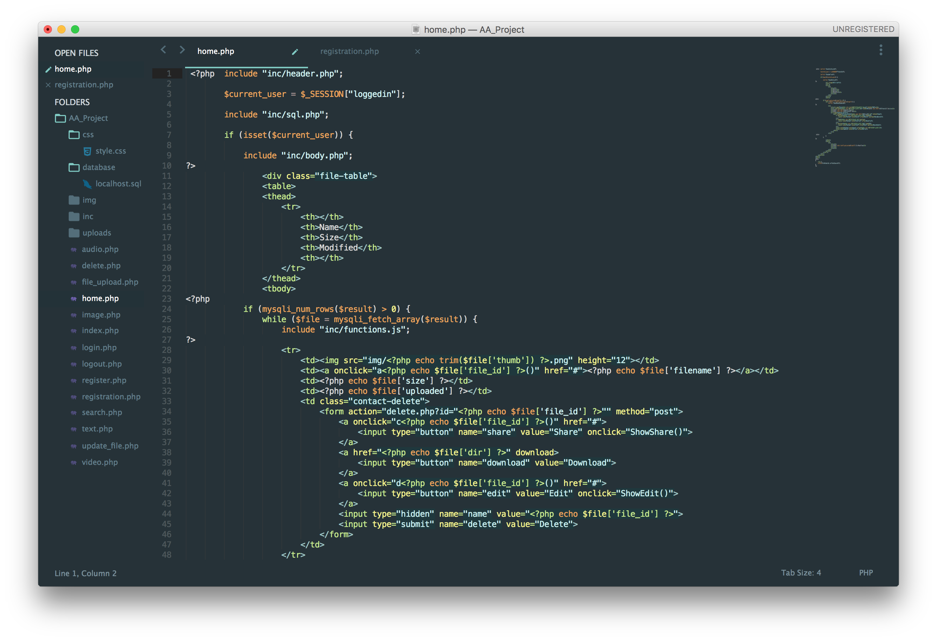

Figure 1.2 - file_upload.php

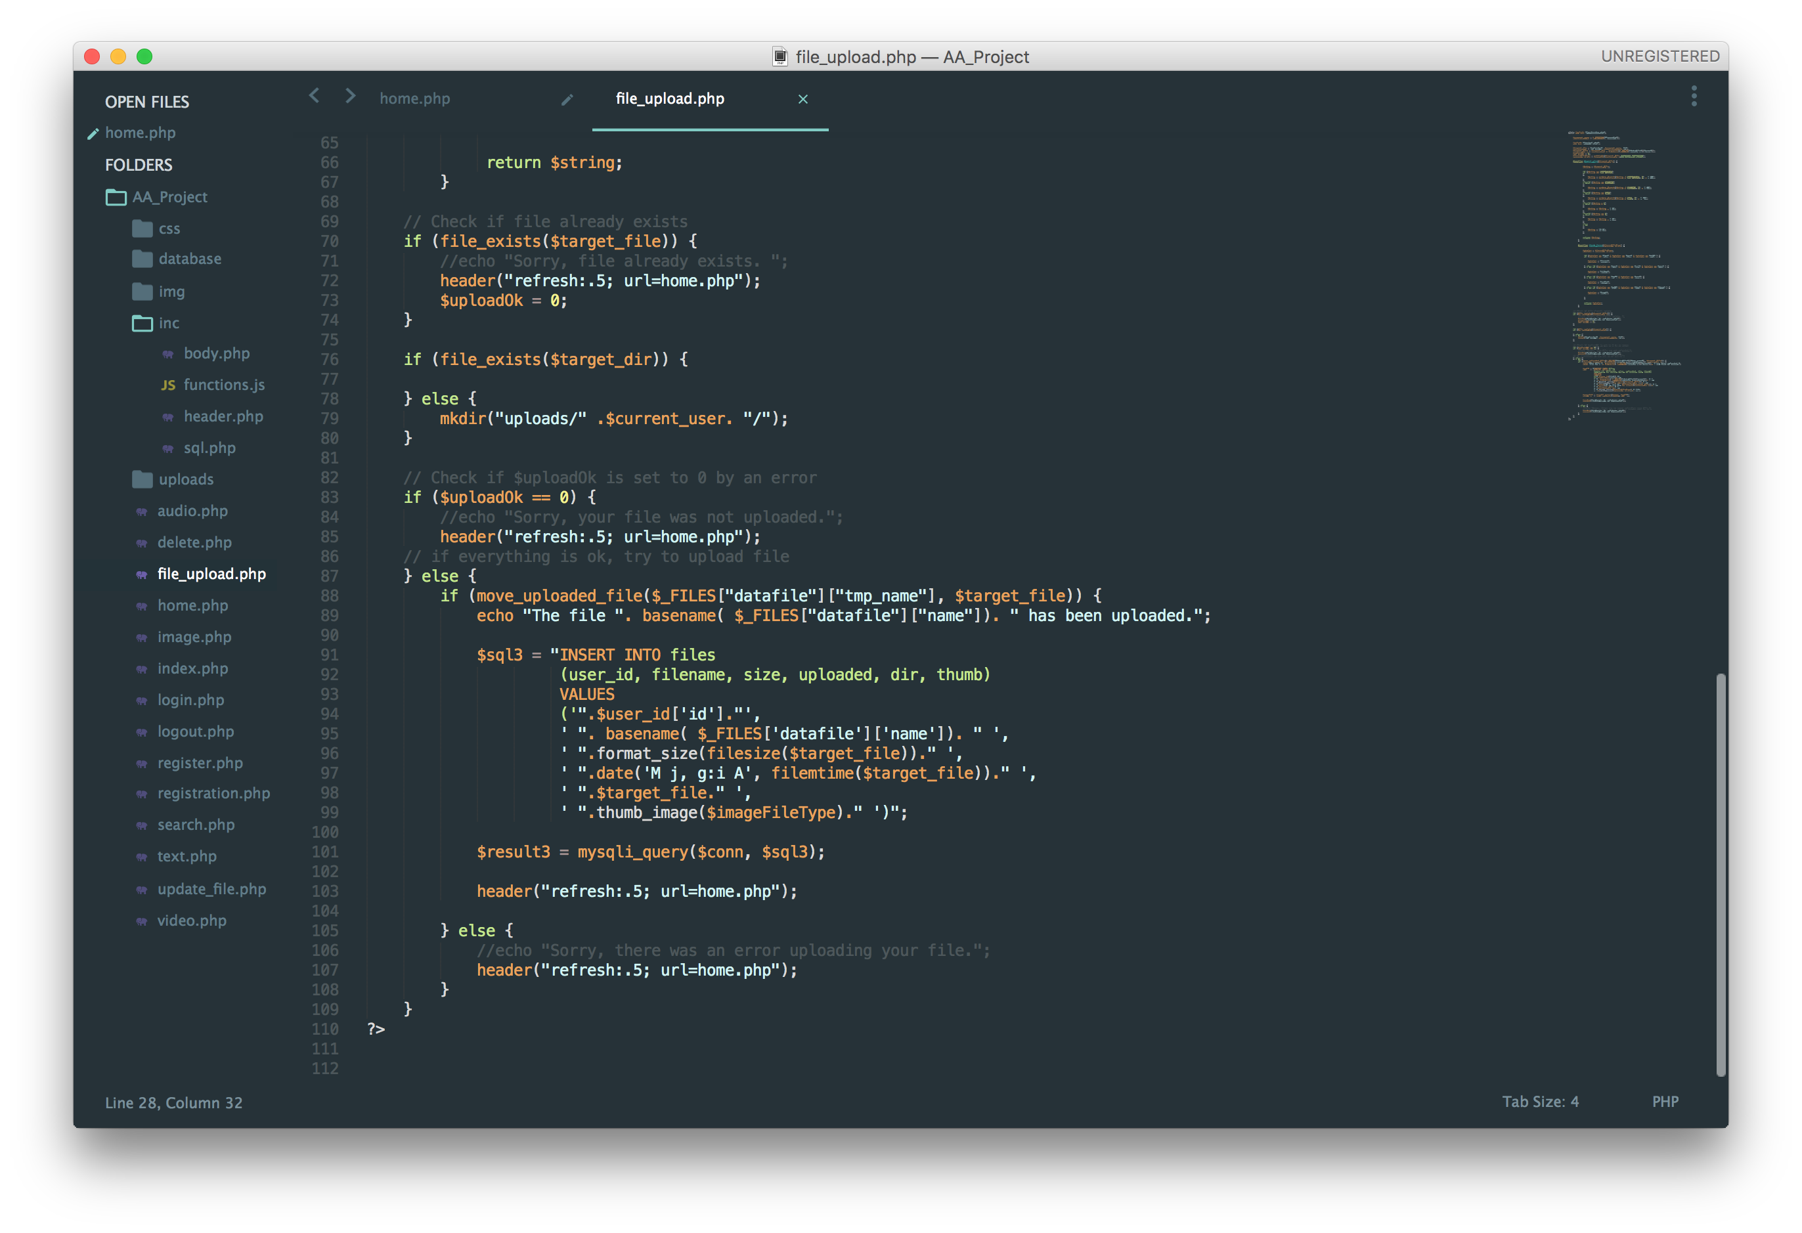

Figure 1.3 - javascript.js

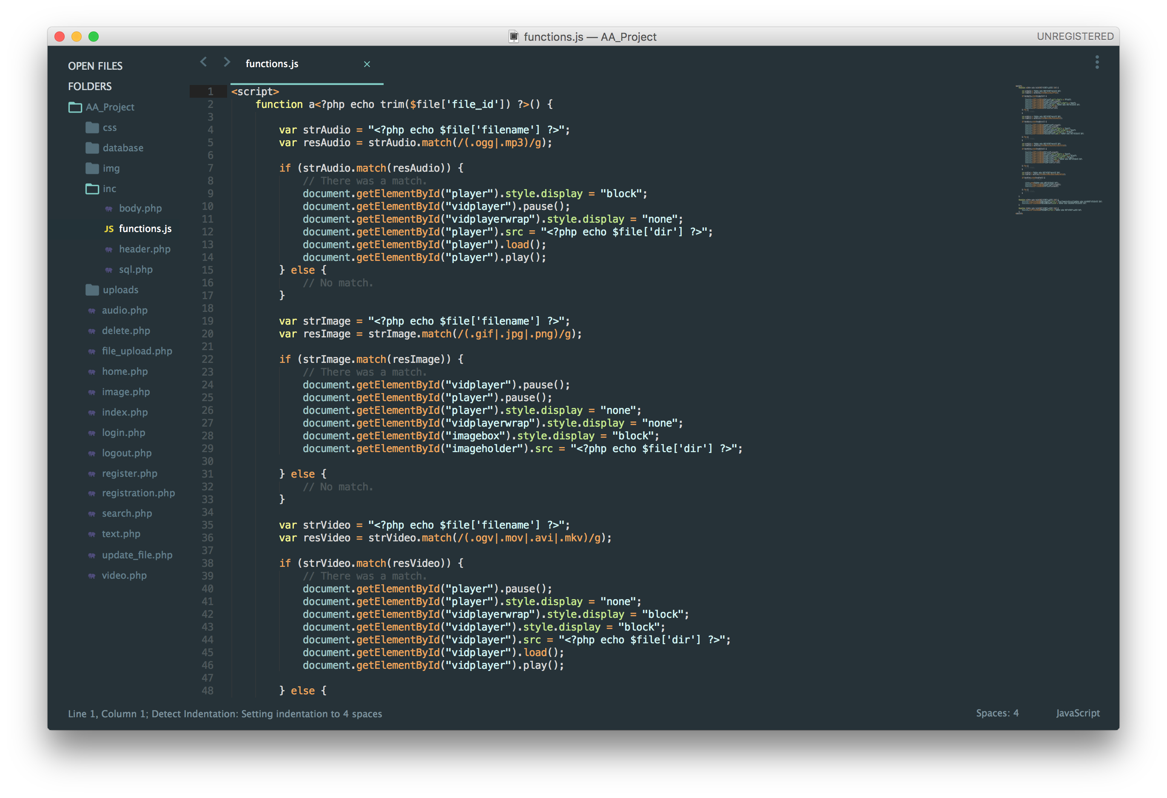

Figure 1.4 - sql.php

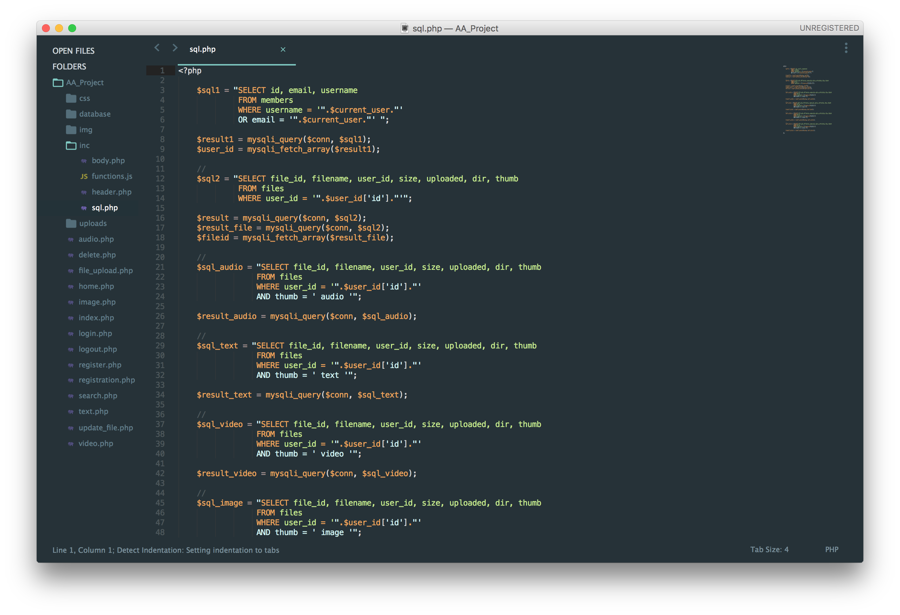Figure 1.5 - style.css